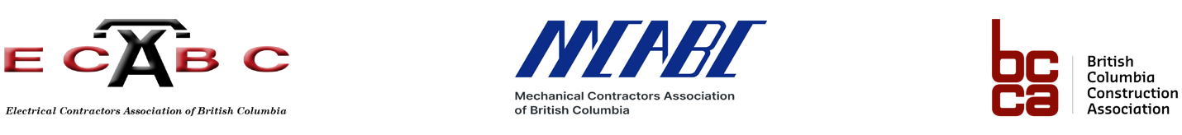

MEDIA RELEASE

BC GOVERNMENT TAKES ACTION TOWARD PROMPT PAYMENT LEGISLATION, ESTABLISHES INDUSTRY WORKING GROUP AS NEXT STEP
Long-awaited progress applauded by leading construction industry advocacy groups

Victoria & Vancouver – January 24, 2022 - The Electrical Contractors Association of BC (ECABC), the Mechanical Contractors Association of BC (MCABC) and the BC Construction Association (BCCA) commend the Provincial government for establishing an industry working group to accelerate progress on prompt payment legislation. The group is tasked with providing industry expertise and guidance to shape development of legislation specifically for BC, informed by work already underway across Canada, the US, and the UK.

Urgent creation of the working group can be attributed to a recent series of Town Hall meetings (November 2021) hosted by ECABC, MCABC, and BCCA, which illuminated the success of legislation in Ontario and showed the strong support for action from BC’s construction industry.

“We are pleased to see this important piece of legislation continue to move forward, and we will be dedicated in our role as part of this working group to ensure our members’ voices are heard and that the process moves swiftly and efficiently towards the implementation of this piece of common sense legislation,” said Deborah Cahill, President of ECABC.

“Our members deserve to always be paid in a timely manner for the work they complete, no matter the market dynamic,” said Kim Barbero, CEO of MCABC. “This has been the basis of our advocacy from the outset and we will continue to advocate for it as members of this newly-established working group. We look forward to working with the Ministry of the Attorney General to advance this work, including how best to ensure it is implemented to help all businesses relying on it throughout B.C.”

“We’d like to thank the many members who have played a key role in moving this issue forward. The formation of this working group is a key towards getting prompt payment introduced in BC, and there is no time to waste. We hope to see this legislation tabled in the Fall 2022 session,” stated Chris Atchison, President and CEO of BCCA.

The working group will be managed by the Ministry of the Attorney General and include industry organizations representing all major stakeholders, as well as BCCA, ECABC, and MCABC. Additional participants will be confirmed and announced shortly. ECABC, MCABC, and BCCA will be providing regular updates to their members throughout the process.

For more information on the need for prompt payment legislation in BC, head to:
https://bccassn.com/industry-priorities/
https://eca.bc.ca/about/advocacy/prompt-payment/
https://mcabc.org/advocacy/prompt-payment/

Media Contact:
Greg Descantes
604-646-3564
gdescantes@pacegroup.com

ECABC, MCABC, and BCCA are professional non-profit organizations representing the largest sectors of BC’s construction industry. Together they have been leading the advocacy efforts on the prompt payment issues for several years.

To find out more about each organization, visit:
https://mcabc.org/
https://bccassn.com/
https://eca.bc.ca/

